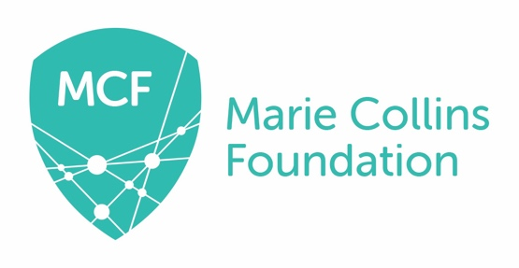

Equality and Diversity Monitoring Form
The intention of monitoring and analysis is to establish if there are different success rates between genders, people of different sexual orientation, ages, different ethnic backgrounds or faiths, and people with disabilities. If there are differences in success rates it will enable action to be taken to ensure that no group is treated unfairly. Your answers will be treated confidentially and will not affect your application in any way.
Title
Surname:
First name:
Age: | 16-24 25-34 35-44 45-54 55-64 65+
Gender: | Male Female Prefer not to say
Gender Identity (if appropriate) | If you identify as transsexual, transgender (in that you have effected a permanent change of gender identity) or as intersex which group do you identify with?  Transsexual Transgender Intersex

Personal Details:

Ethnic origin: Please tick against one of the following:
Asian or Asian British  Bangladeshi  Indian  Pakistani  Any other Asian background  Please specify below if you wish.......  ........................................................................ |  | Mixed  Black and White Caribbean  Black and White African  Asian and White  Any other mixed background  Please specify below if you wish.......  ........................................................................
Black or Black British  African  Caribbean  Any other Black background  Please specify below if you wish.......  ........................................................................ |  | White  British  English  Irish  Scottish  Welsh  Any other White background  Please specify below if you wish.......  ........................................................................
Chinese or Other ethnic group  Chinese  Any other  Please specify below if you wish.......  ........................................................................ |  | Prefer not to say

Disability: Please tick against one of the following:
Do you consider yourself to have a disability under the Equality Act 2010?
In the Act, a person has a disability if:

- they have a physical or mental impairment

- the impairment has a substantial and long-term adverse effect on their ability to perform normal day-to-day activities

For the purposes of the Act, these words have the following meanings
- 'substantial' means more than minor or trivial
- 'long-term' means that the effect of the impairment has lasted or is likely to last for at least twelve months (there are special rules covering recurring or fluctuating conditions)
- 'normal day-to-day activities' include everyday things like eating, washing, walking and going shopping
Yes No Prefer not to say

Please describe the nature of your disability

This information is provided for monitoring purposes only – if you need any reasonable adjustments you should arrange these separately.

No religion  Baha’i  Buddhist  Christian  Hindu  Jain |  | Jewish  Muslim  Sikh  Other  Please specify below if you wish……………………………………………………………..………………………  Prefer not to say
Religion or belief: Please tick against one of the following

Sexual Orientation: Please tick against one of the following
Bisexual  Gay Woman/Lesbian  Transgender  If you prefer to use your own term, please specify here___________ |  | Gay Man/Homosexual  Heterosexual/straight  Prefer not to say

Thank you for completing this form

